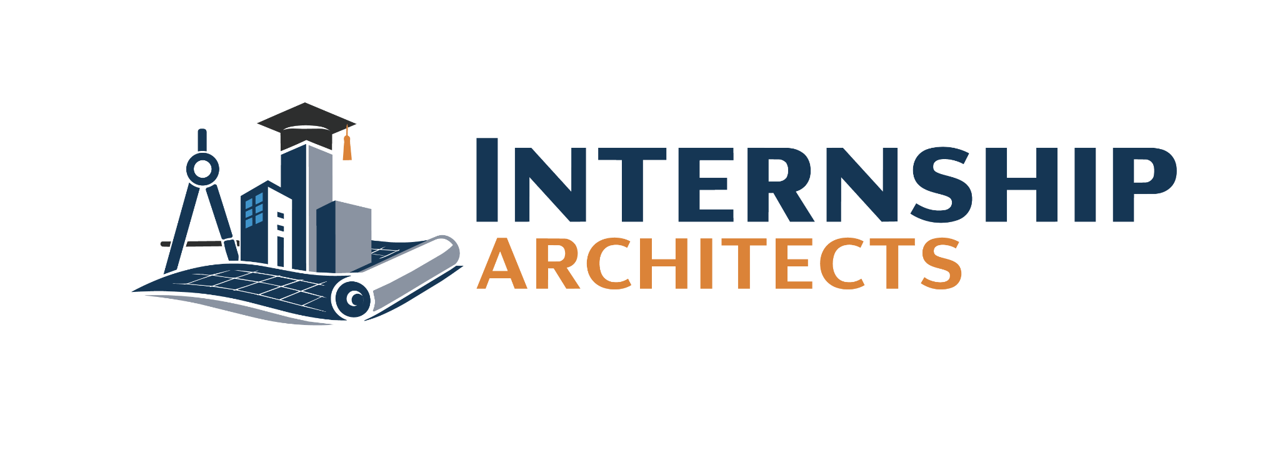

CHECKLIST

SAMPLE BEHAVIOR
Directions: Review the career readiness competency sample behaviors provided by the National Association for Colleges and Employers (NACE). Check off any of the behaviors you have executed in the past. These can be from any type of activity including: classes, jobs, clubs, sports, community service/volunteer work, or life.

CRITICAL THINKING
- Make decisions and solve problems using sound, inclusive reasoning and judgment.
- Gather and analyze information from a diverse set of sources and individuals to fully understand a problem.
- Proactively anticipate needs and prioritize action steps.
- Accurately summarize and interpret data with an awareness of personal biases that may impact outcomes.
- Effectively communicate actions and rationale, recognizing the diverse perspectives and lived experiences of stakeholders.
- Multi-task well in a fast-paced environment.

COMMUNICATION
- Understand the importance of and demonstrate verbal, written, and non-verbal/body language abilities.
- Employ active listening, persuasion, and influencing skills.
- Communicate in a clear and organized manner so that others can effectively understand.
- Frame communication with respect to diversity of learning styles, varied individual communication abilities, and cultural differences.
- Ask appropriate questions for specific information from supervisors, specialists, and others.
- Promptly inform relevant others when needing guidance with assigned tasks.

TECHNOLOGY
- Navigate change and be open to learning new technologies.
- Use technology to improve efficiency and productivity of work.
- Identify appropriate technology for completing specific tasks.
- Manage technology to integrate information to support relevant, effective, and timely decision-making.
- Quickly adapt to new or unfamiliar technologies.
- Manipulate information, construct ideas, and use technology to achieve strategic goals.

PROFESSIONALISM
- Act equitably with integrity and accountability to self, others, and the organization.
- Maintain a positive personal brand in alignment with organization and personal career values.
- Be present and prepared.
- Demonstrate dependability (e.g., report consistently for work or meetings).
- Prioritize and complete tasks to accomplish organizational goals.
- Consistently meet or exceed goals and expectations.
- Have an attention to detail, resulting in few if any errors in work.
- Show a high level of dedication toward doing a good job.

TEAMWORK
- Listen carefully to others, taking time to understand and ask appropriate questions without interrupting.
- Effectively manage conflict, interact with and respect diverse personalities, and meet ambiguity with resilience.
- Be accountable for individual and team responsibilities and deliverables.
- Employ personal strengths, knowledge, and talents to complement those of others.
- Exercise the ability to compromise and be agile.
- Collaborate with others to achieve common goals.
- Build strong, positive working relationships with supervisor and team members/coworkers.

Source: National Association of Colleges and Employers (NACE), Career Readiness Competencies
National Association of Colleges and Employers. (2024). Career readiness defined

