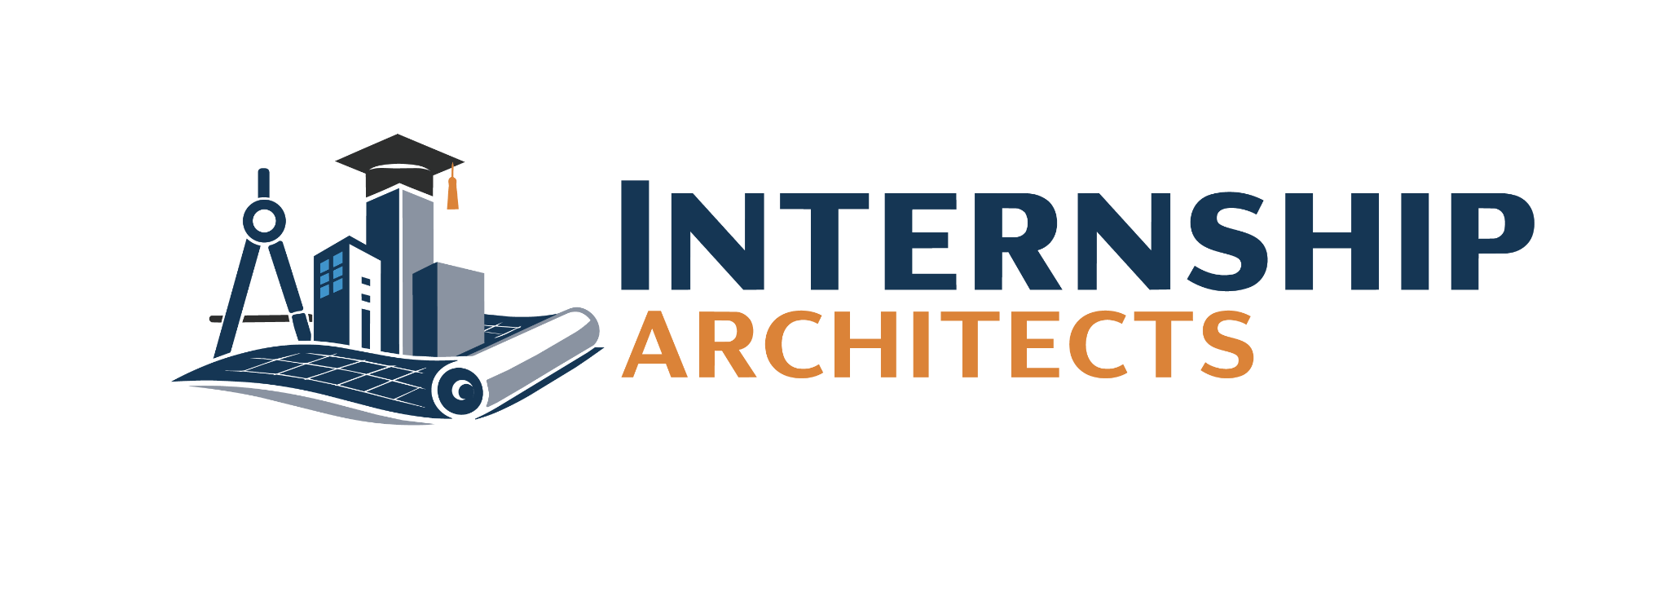
ACTIVITY

INTERVIEW PREPARATION, COMPANY
Being prepared for an interview requires self reflection (see the brainstorm activity) and research about the position, company, and people. Complete this activity to learn about how to research.
Directions: Find an internship/job posting of interest to you. Ideally one you have applied to, but if not find one now. Using that job posting, fill in all the requested information to help you strategize how to prepare for an interview for that position. The gray type is information you should be gathering. The orange type is questions you should be answering.

INTERNSHIP/JOB POSTING
Find a job posting and use that to model how to research and prepare for an interview.
Position:
What is the position title:
What makes me excited about this position?

What am I uncertain about?

Duties/Responsibilities:
Record the major duties/responsibilities listed in the job description:

Which duties/responsibilities do I have experience with?

What are examples of times where I demonstrated these duties/responsibilities?

Which duties/responsibilities do I NOT have experience with?

How could I overcome these deficiencies?

Minimum Qualifications:
Record the minimum qualifications:
Do I meet the minimum qualifications?

If not, how could I overcome this deficiency?

Preferred Qualifications;
Record any preferred qualifications:
What qualifications do I have?

What are some examples of times I used these qualifications?

What qualifications am I most excited about?

Why?

Are there any preferred qualifications that you are really excited to learn and use in the future?

Personal connections (ask anyone you know with a connection to the position including anyone with a similar position at a different company or someone who works for that company):
What did you learn from your personal connections about the position?

What do they like and not like about the position?

AI Research about the position:
What did you learn about the position from AI?

Additional Information:
Any other important information gathered from the posting:

Overall:
Why would I be good at this position?

Why should they hire me?

What questions do I want answered about the position?

COMPANY
To be well prepared for an interview, you need to learn about the company as well.
Company:
What do I already know about this company?

Why am I interested in working for this company?

Do I know anyone who works for this company? Talk with them before the interview.

Learn more about the company by evaluating the following.
Website:
Company philosophy, vision, mission, values and/or principles:

How do you feel about these? Do they align with your values?

Brag points (what are they boasting)?:
How do you feel about these points? Would you agree or disagree these are important things about the company?

What did you learn about the company?:
What do you like about the company, to be specific?

What don’t you like about the company?

Department on Website:
What can you learn or ascertain about the department the position you are applying to is in?

Location(s):
What familiarity do you have with this location?

Any important information/documents (Strategic plan, annual report, etc.) on the website?:
What did you learn from these documents?

Additional Notes:

LinkedIn Company Page
What did you learn about the company?:

People who work there:

Additional Notes:

Facebook
What did you learn about the company?:

Additional Notes:

Instagram
What did you learn about the company?:

People who work there:

Additional Notes:

Glassdoor Reviews
What did you learn about the company?:

Additional Notes:

Other Social Media (TikTok, X….)
What did you learn about the company?:

People who work there:

Additional Notes:

AI/General Web search
Has the company been in the news recently? For what reasons?

What companies are similar to it or competitors?

How is this company different from the competition?

Personal Connections (ask anyone you know with a connection to the company including past or current employees, others at similar companies, customers):
What did you learn from your personal connections about the company?

What do they like and not like about the company?

Competitors (finding a list of competitors and what makes this company unique):

Overall Impression of the company:
Why do I want to work for this company?

What 3 things excite me most about the company?

What are some reservations I have about the company?

What questions do I want to ask in the interview to learn more about the company?

__________________________________________________________________________________

PEOPLE
Ask when setting up the interview and through your research, find out about the people interviewing you and would be on your team. Use the company website and LinkedIn to gather this information.

Record anything you know about the people at this company.
Supervisor/boss:

People on the team:

Executives:

Personal connections (ask anyone you know who knows someone who works on the team or knows the supervisor):

What did you learn from your personal connections about the people?

What do they like and not like about the people?

