
REFLECTION

Reflection and action steps are the best practice for fully incorporating a lesson into your life. Take your time and really think through your answers and make a plan for yourself.

At the end of each Internship Architect’s course, there will be a Reflection. Be sure to thoughtfully reflect on what you have learned and how you will proceed.
View the tabs on the left to complete the reflection for the appropriate course. By having them in all one place, you will only have one document with all reflections. Be sure to complete the correct one as you may not be taking all of the courses.
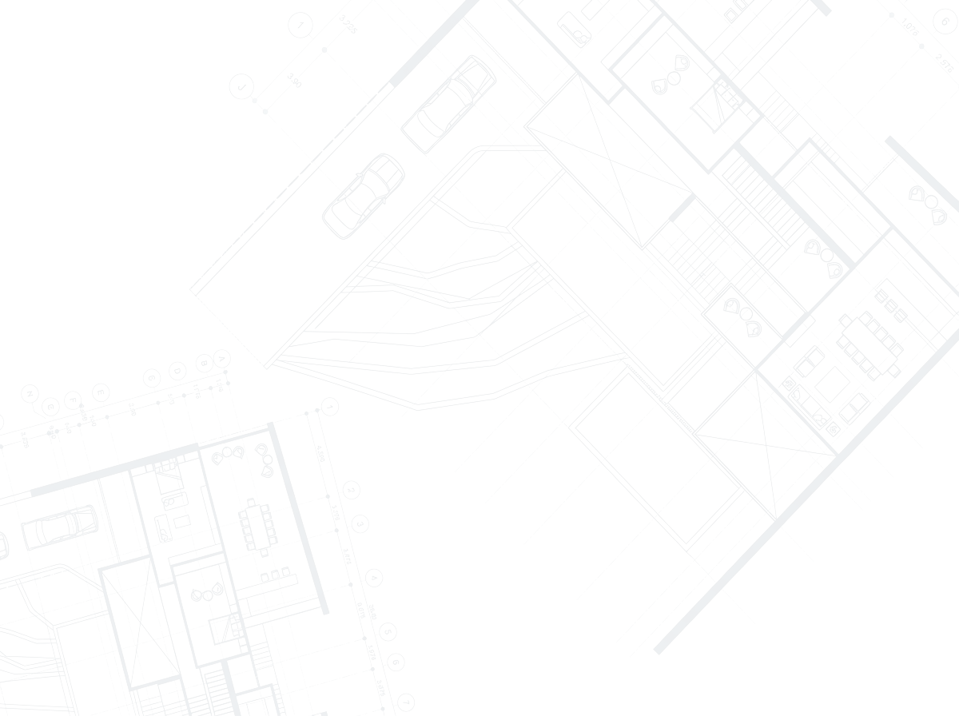

REFLECTION

BUILDING A CAREER FOUNDATION
Reflection and action steps are the best practice for fully incorporating a lesson into your life. Take your time and really think through your answers and make a plan for yourself.

After completing the Building Your Career Foundation course, where we talked about what employers want and the career readiness competencies, complete this reflection exercise.

- What is one “take away” you learned from this lesson?

- What are your two strongest competencies and why?

- What is one way you will improve on your weakest competency?

- What will you do with this knowledge?

REFLECTION

RESUMES: DRAFTING
Reflection and action steps are the best practice for fully incorporating a lesson into your life. Take your time and really think through your answers and make a plan for yourself.

After completing the Resumes: Drafting course, which was a workshop to produce a draft of your resume, complete this reflection exercise.

- What is one “take away” you learned from this lesson?

- On a scale from 1-10 how do you feel about your resume?

- What is one aspect of your resume that makes you proud?

- Writing a resume allows us to see what we are offering to employers. Review your resume objectively as an employer with a critical eye. Are there any gaps on your resume? Not enough work experience? Not involved in anything? No relevant experience? If there are gaps, what could you do to improve your resume?

- What will you do with this knowledge?

REFLECTION

RESUMES: FORMATTING
Reflection and action steps are the best practice for fully incorporating a lesson into your life. Take your time and really think through your answers and make a plan for yourself.

After completing the Resumes: Formatting course, which was a workshop to ensure your resume followed traditional style resume formatting guidelines, complete this reflection exercise.

- What is one “take away” you learned from this lesson?

- Why is proper formatting of a resume important?

- On a scale of 1 (not at all) to 5 (met all), your resume–before the lesson–met all the formatting expectations?

- What do you need to change on your resume?

REFLECTION
RESUMES: BULLET WRITING
Reflection and action steps are the best practice for fully incorporating a lesson into your life. Take your time and really think through your answers and make a plan for yourself.

After completing the Resumes: Bullet Writing course, which helped you write strong, competency-focused, detailed resume bullets, complete this reflection exercise.

- What is one “take away” you learned from this lesson?

- What 2-3 competencies do you want to highlight on your resume? How many bullets reflect these competencies?

- At this point, do you have a general networking resume or one that is tailored to your career field of interest?

- How will you improve your resume based on this lesson?

REFLECTION
LINKEDIN
Reflection and action steps are the best practice for fully incorporating a lesson into your life. Take your time and really think through your answers and make a plan for yourself.

After completing the LinkedIn: Profile and Use course, which helped you develop a strong, professional LinkedIn profile and learn to use the platform, complete this reflection exercise.

- What is one “take away” you learned from this lesson?

- What phrase are you using in your headline regarding your passion, skills, career interest? Is this same idea reflected in your other personal brand materials? If not be sure to update those items as well

- How many network connections do you have on LinkedIn? We encourage you to have at least 200. What will you do to get to that number?

- List at least 3 alumni you found using the LinkedIn alumni tab who would be good networking contacts for you. What connection are they to you, a 1st, 2nd or 3rd?

REFLECTION

INTERNSHIP & JOB SEARCH
Reflection and action steps are the best practice for fully incorporating a lesson into your life. Take your time and really think through your answers and make a plan for yourself.

After completing the Resumes: Bullet Writing course, which helped you write strong, competency-focused, detailed resume bullets, complete this reflection exercise.

- What is one “take away” you learned from this lesson?

- Why do you think job boards/databases are not the best search tool?

- What companies will you (would you) target for your search (list at least 5)?

- Who in your network works at (or worked previously) at these 5 target companies? If no one currently, how will you find someone?

