
ACTIVITY

RESUME BULLET WRITING
How to construct resume bullets that will get you the attention you deserve. Complete this Resume Bullet Writing Activity.
Refer to the work you did on the Resume Content Writing Brainstorm Activity from earlier in the course. Start with the same experience you used on the Resume Content Writing Brainstorm Activity. Think about how you utilized each competency at this experience?
Directions:
- For each career readiness competency, think about how you used it at an experience.
- Fill in details especially being specific or any results.
- Choose some action verbs that express what you want to say (refer to the Action Verb list)
- Put it all together in a bullet.
- Use the graphic organizer below to help you.
- Do it for EACH competency for that one experience.
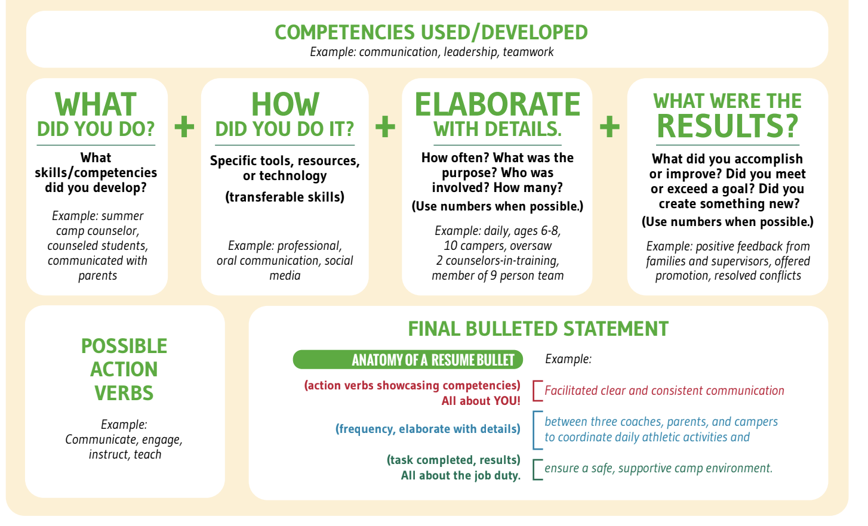

TECHNOLOGY (Understand and leverage technologies ethically to enhance efficiencies, complete tasks, and accomplish goals)

What did you do?

How did you do it?

Elaborate with details.

What were the results?

Action verbs:

BULLET:

CRITICAL THINKING (Identify and respond to needs based upon an understanding of situational context and logical analysis of relevant information)
What did you do?

How did you do it?

Elaborate with details.

What were the results?

Action verbs:

BULLET:

COMMUNICATION (Clearly and effectively exchange information, ideas, facts, and perspectives with persons inside and outside of an organization)

What did you do?

How did you do it?

Elaborate with details.

What were the results?

Action verbs:

BULLET:

PROFESSIONALISM (Knowing work environments different greatly, understand and demonstrate effective work habits, and act in the interest of the larger community and workplace)
What did you do?

How did you do it?

Elaborate with details.

What were the results?

Action verbs:

BULLET:

TEAMWORK (Build and maintain collaborative relationships to work effectively toward common goals, while appreciating diverse viewpoints and shared responsibilities)

What did you do?

How did you do it?

Elaborate with details.

What were the results?

Action verbs:

BULLET:

