
ACTIVITY

SEARCH

We are going to cover a few search strategies. As each strategy is introduced in the videos, you will do a portion of this activity.

Database Activity
Directions: Using Handshake, Indeed, LinkedIn or some other job posting site, do a search for positions of interest. It can be as broad or as focused as you are at this time (i.e. business intern to human resources benefits intern). Even if you are not ready to begin an active search yet, do this to get some ideas of deadlines/timelines, etc. Once you have found a posting of potential interest, list on this activity: the title, company, and competencies/skills listed in the posting.
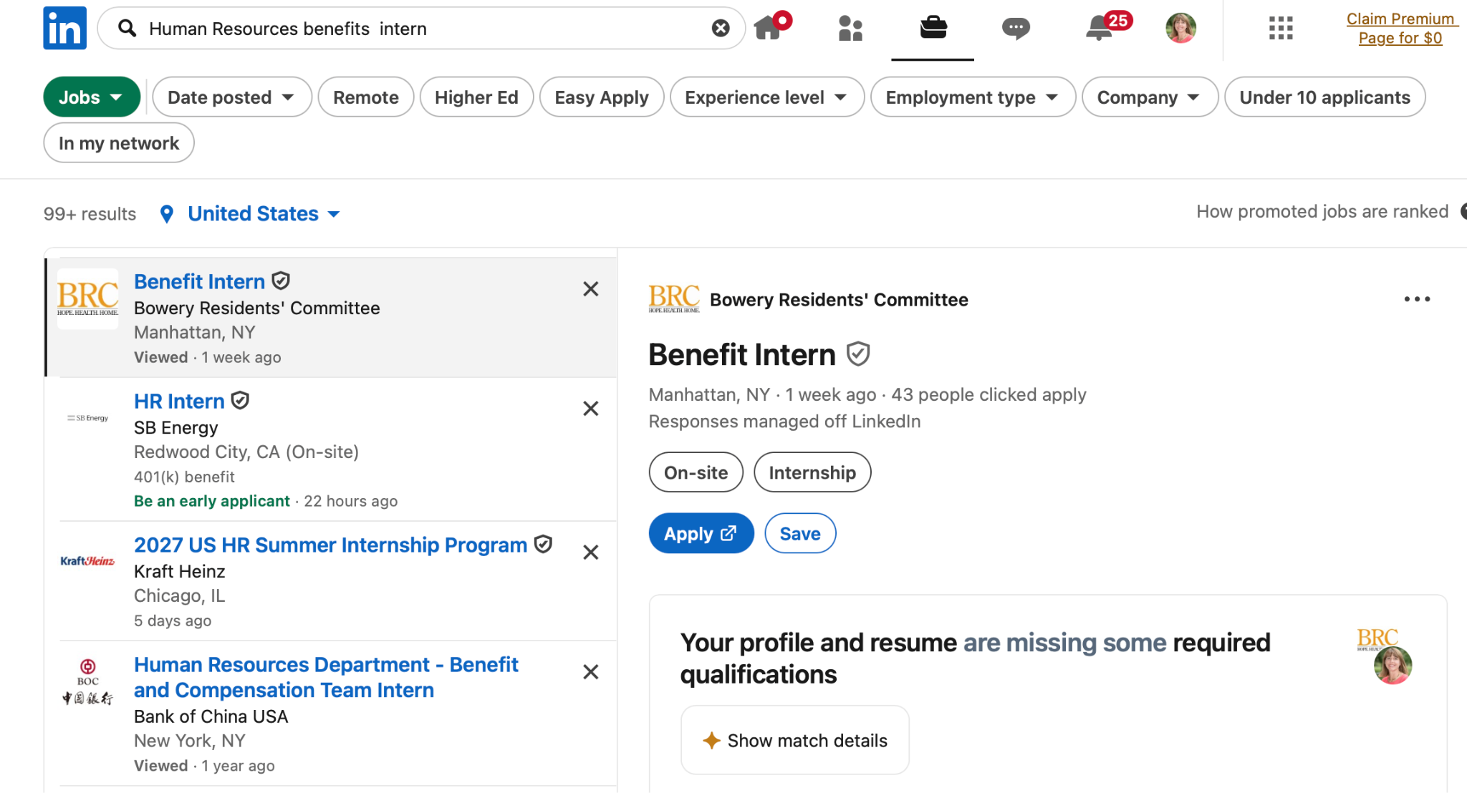
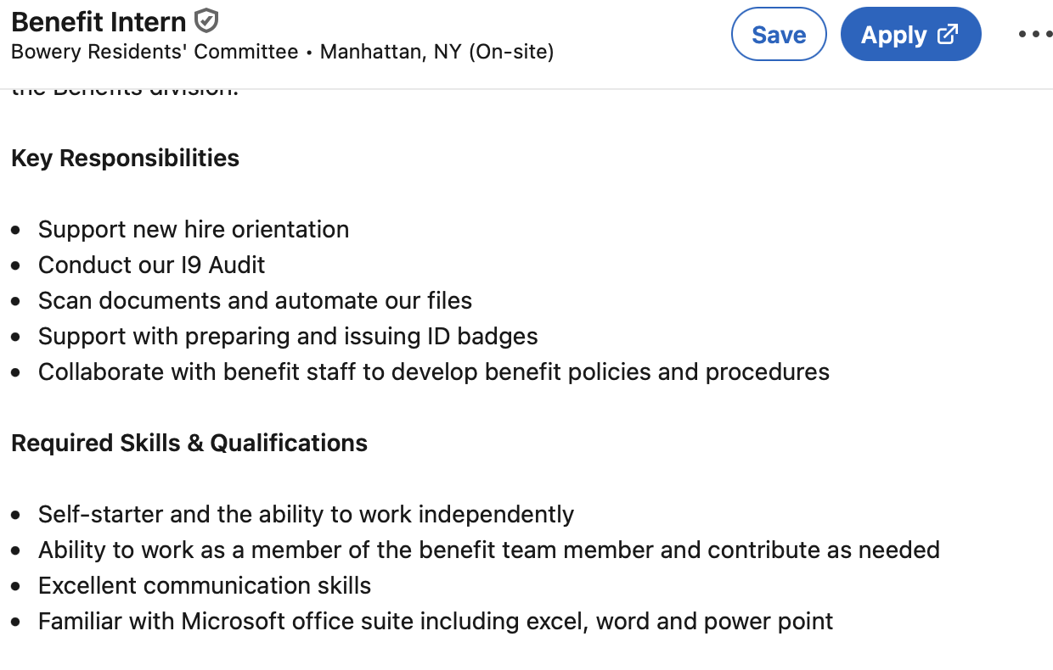
List 3 positions you found by searching a database or two:

1)
Title of position:
Company:
Competencies/Skills asked for in job posting:

2)
Title of position:
Company:
Competencies/Skills asked for in job posting:

3)
Title of position:
Company:
Competencies/Skills asked for in job posting:

Directions: Using Google or an AI tool find some niche job boards or professional associations that have job boards. List at least 2 here with links to the website.

1)
Organization name:
Link to job board:

2)
Organization name:
Link to job board:

STOP HERE and watch the next video lesson

____________________________________________________

Target Activity
Directions: Step 1: To target some companies of interest, identify five companies of interest to you. List them below. These could be companies you know of in your area, “dream” companies where you would like to work or companies with good reputations.
Step 2: For each company listed, look on their websites for a “careers” tab/page and see what positions are currently available. Copy that link below. Step 3: Review any job openings. List below any positions that are of interest. There may be none and that’s okay, there might be some posted but not of interest to you or there might be more than you thought. This exercise is to get you started, you can return to it frequently



1)
Company:
Website link to careers tab:
Title of position(s):

2)
Company:
Website link to careers tab:
Title of position:

3)
Company:
Website link to careers tab:
Title of position:

4)
Company:
Website link to careers tab:
Title of position:

5)
Company:
Website link to careers tab:
Title of position:

STOP HERE and watch the next video lesson
____________________________________________________________________________________

Brainstorm Activity
Directions: Answer these questions and do some research (this is a good use of AI) to help you create a list of companies to target for your position search.

Try to list 3-5 ideas for each question! If you can’t come up with things on your own, do a Google/AI search

Company Search
- What companies did you list as “target” companies?
  - Example–Nike

- What are similar or competitor companies to the companies listed above?
  - Example–New Balance, UnderArmor, Adidas

Career field Search
- What is your career field(s) of interest?
  - Example-product design

- What are some companies you know hire in that field?

Keep thinking:
- What are companies/industries that are growing/hiring? (If you don’t know, ask AI or do some research).
  - Example-Albany Med, healthcare, nursing

- What products do you use/like (apps, sports equipment, hygiene products, electronics, food, cars, clothing, ride share apps, vacation planning….)
  - Example-Whole Foods, Uber, BMW

- Who else makes similar products?
  - Example-BWM-Audi, Mercedes, Lexus, Volvo, Tesla

- Service providers (phone plan, gym membership…)
  - Example-Verizon, Spotify

- Hobbies you have (companies that teach, make products)
  - Example-Tennis-raquets: Wilson, Dunlap, Prince… balls: Wilson, Penn, Dunlap

- Heard good things about the company (local news)
  - Example: UHY, Sunmark Federal Credit Union

- Are in your geographical area of interest (Google/AI produced list)

- Where do you have network connections? (LinkedIn, contacts)

- Non-profit organizations whose causes you support (local, regional, national)
  - Example: Mohawk Hudson Humane Society, ASPCA

Directions: Filling in the matrix might help you brainstorm/identify companies of interest. Take things you listed above and continue to think of options by using the matrix below to brainstorm.

Brainstorming Matrix

Question | Prompts | Example | Your Ideas
Products | Foods | Bagels | Brueggers, Thomas,  Cream cheese,
Hobbies | Skiing | Equipment, ski areas, clothing | Fischer, Killington, NorthFace

All of these companies hire people like you, go find out about them!!!
____________________________________________________________________________________

Network Activity
Directions: List people in each category that you could use to help you with your internship/career search. They could be in the same field, know people in the field, work at a company of interest (in the same or different departments), know you well, or are well connected themselves. You never know who knows someone who can be of help to you.

3 Professors/teachers/advisors/administrators

3 Family members

3 Friends’ family members (high school or college friends do they have any relatives)

3 Co-workers, supervisors,

6 Friends, classmates, teammates…

